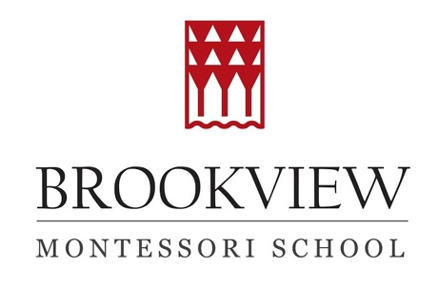

ELEMENTARY SUMMER CAMP THEMES FOR 2025

Dates | Teacher | Theme | Description
June 9-13 | Maggie Bischoff | Social-Emotional Learning | It’s a SEL-ebration! We’ll kick off the summer with a week of fun-filled social-emotional learning. Each day will be dedicated to exploring one of the five major competencies of SEL. Activities will include songs, games, books, and art projects designed to help students learn about themselves and how to relate to others.
June 16- 20 | Jack Kallicragas | Meta-Gaming! | Students will play tabletop games, but that’s just a start! Children will also invent their own games, and construct the materials needed to make those games work. Finally, we will experiment with imaginative, game-like role playing scenarios.
June 23-27 | Deborah Christy | Drama and Creative Games | Let’s stretch our imaginations as we learn drama games infused with creative movement in order to expand body awareness and to enhance character development. Campers will be expanding their skills in coordination, concentration, confidence, and collaboration!
June 30-July 3 | Jane Cowley | Art and Sculpture | This will be a very creative week with our very own artist-in-residence, Ms. Jane, whose artwork has been seen in galleries throughout the region. Students will receive an introduction to the art of Alexander Calder and Alberto Giacometti. They will also create sculptures and mobiles using various materials.
July 7-11 | Larry Schanker | A Musical Cornucopia | During this week, we will investigate many styles of music, including jazz, classical, folk, and pop. As a part of this exploration, we will listen to music from many different countries and play instruments together in the various styles we have heard. Finally, students will learn how to construct their own piece of music, and about the various musical elements we think about as composers.
July 14-18 | Jane Cowley | Plein Air Painting | "En plein air" refers to the practice of painting outdoors, directly from nature, capturing the essence of a landscape or subject by incorporating natural light, color, and movement. Students will enjoy art as a peaceful, outdoor experience (or while viewing nature from indoors, if the weather doesn’t cooperate).
July 21-25 | Jack Kallicragas | Brookview Builders! | During this week, students will explore engineering ideas and creative construction concepts. We will start with small projects and then design and build some beautiful new playground equipment!
July 28- Aug 1 | Lindsay Gaspari | Titani-Camp! | Learn about the Science behind the ship. Hear stories about the Titanic, the interesting passengers and crew, and enjoy a S.T.E.A.M. powered week of learning, including creating your own artwork and poetry to become a part of the history.
Aug 4-8 | Maggie Bischoff | Geology | Rock around the clock with Ms. Maggie! We will explore gems, minerals, fossils, and more. Activities will include studying the rock cycle, specimen identification, and breaking geodes.
Aug 11-15 | Maggie Bischoff | The Five Senses | This final week of camp will involve lessons, games, projects, and activities to bring awareness to how we take in information about the world around us. Each day will focus on one of our five senses.

